Mount Barker Community Bank® Branch
And Walpole Agency

Community Sponsorship Application Form 2019/2020

Applications that do not include the required information or are late
may not be considered by the Board.

Sponsorship Applications must be received by
Plantagenet Community Financial Services Ltd by
Close of business Thursday 2nd May 2019

Late, incomplete or unsigned applications will NOT be accepted

Please read the ‘Sponsorship Guidelines’ to assist in completing this application.

How to submit your application:

Post
PO Box 117, Mount Barker WA 6324

Email
pcfs@westnet.com.au

Deliver by Hand
Mount Barker Community Bank Branch Bendigo Bank
4 Short Street, Mount Barker WA 6324
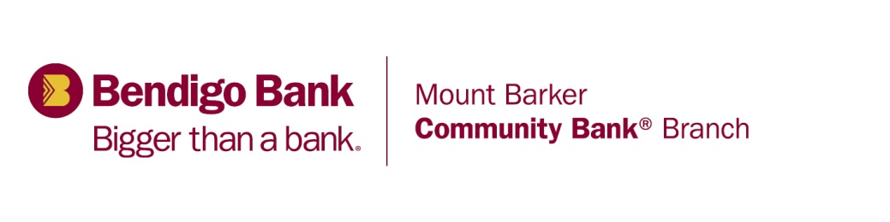
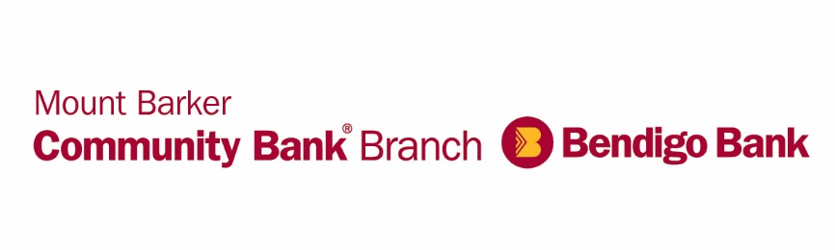
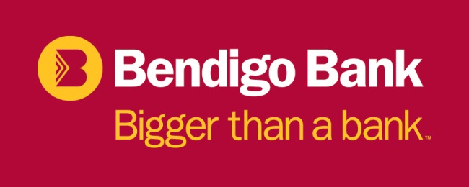

What it means to be
Bigger than a bank.

At Mount Barker Community Bank® Branch we recognise that local clubs, projects and community groups are an important part of the community. That’s why we show our support in many different ways – with over $1m invested back in to our local communities in over 17 years of operation.

As a Bendigo Bank customer you benefit from a great range of competitive products and personal service, plus the satisfaction of knowing your banking is contributing to Region community.

It’s not a new thing, it’s simply who we are and what we believe in. We think that Bendigo Bank can only be successful if our customers and our communities are successful.

So just by banking with us, you’re automatically part of something bigger.

Drop in to your local branch and meet our friendly team of staff and be part of something bigger.
Community Sponsorship Application 2019/2020

SECTION A

Applicant Information

Name of Organisation: ________________________________________________________________
___________________________________________________________________________________
Postal Address:______________________________________________________________________
Street Address (office or premises): ______________________________________________________
___________________________________________________________________________________

Contact Person

Name: _____________________________________________________________________________
Position: ____________________________________________________________________________
Telephone: ________________________________ Mobile: ______________________________
Email: _____________________________________________________________________________

I, being the contact person listed above, acknowledge that the above organisation accepts the terms and conditions of the sponsorship, as outlined on page 5.

Is your organisation an incorporate body? Yes  No 
Are you registered for GST purposes? Yes  No 
If yes, please provide your ABN: ______________________________________________
Does your organisation bank with the Bendigo Bank? Yes  No 

SECTION A – Continued

General Information about your Organisation

Describe the main purpose of your organisation and the services it provides:
___________________________________________________________________________________
___________________________________________________________________________________
___________________________________________________________________________________
___________________________________________________________________________________
___________________________________________________________________________________
___________________________________________________________________________________
___________________________________________________________________________________
___________________________________________________________________________________
___________________________________________________________________________________
___________________________________________________________________________________
___________________________________________________________________________________

Please provide membership numbers for the last 3 years:
2018 / 2019 - _______________ 2017 / 2018 - _______________ 2016 / 2017: ______________

Do you have any other relevant information about your organisation?
___________________________________________________________________________________
___________________________________________________________________________________
___________________________________________________________________________________
___________________________________________________________________________________
___________________________________________________________________________________
___________________________________________________________________________________

Has the Mount Barker Community Bank® previously provided a Community Sponsorship to your organisation? Yes  No 

If yes, please advise:

The date of last sponsorship: _____________________________________

The amount of last sponsorship: __________________________________

Purpose of the last sponsorship: ___________________________________________________________________________________

Details of how the Mount Barker Community Bank® was acknowledged: ________________________

___________________________________________________________________________________

___________________________________________________________________________________

___________________________________________________________________________________

___________________________________________________________________________________

SECTION B – Sponsorship Request

Please provide the following details
Reason for the Sponsorship
___________________________________________________________________________________
___________________________________________________________________________________
___________________________________________________________________________________
___________________________________________________________________________________
___________________________________________________________________________________
___________________________________________________________________________________
___________________________________________________________________________________
___________________________________________________________________________________
Benefits of project / who will benefit?
___________________________________________________________________________________
___________________________________________________________________________________
___________________________________________________________________________________
___________________________________________________________________________________
___________________________________________________________________________________
Management and Monitoring of Project
___________________________________________________________________________________
___________________________________________________________________________________
___________________________________________________________________________________
___________________________________________________________________________________

Name of Event / Project

Date of Event / Project

Location of Event / Project

Total cost of Event / Project

Amount of sponsorship requested $______________________ inc / exc GST

Please attach the following to this application:
- Any additional information that you believe will assist this application;
- A copy of the audited financial statements for your organisation for the last financial year is preferred. The minimum requirement is the organisations most recent profit and loss statement and balance sheet;
- Quotes etc that support dollar amounts of the project; and
- Plans or diagrams that easily illustrate your request, if applicable.

SECTION B - Continued

Estimated Project Costs & Funding Sources

Please specify and name source of funding and attach full details of expenditure, with supporting quotes if applicable.

Expenses
Equipment | $
Materials | $
Promotions | $
Consumables | $
Labour | $
Other | $
Total Expenses | $

Income
Amount requested from Community Bank | $
Own monetary contribution | $
Non-monetary contribution | $
Other Grants applied for / received | $
 | $
Other | $
Total Income | $

*(Please list key components of your project, eg. materials, promotions, value of in-kind contributions, fees, etc)

Please note that Total Income must equal Total Expenses

Details of other Financial Assistance Applied for

Have you applied or do you intend applying to any other funding body or community group for assistance with this project? Yes  No 

If yes please provide details: ___________________________________________________________
___________________________________________________________________________________
___________________________________________________________________________________
___________________________________________________________________________________
___________________________________________________________________________________

SECTION C – Promotional Opportunities

Please indicate which of the following promotional opportunities are available to the Mount Barker Community Bank® Branch if your application is successful.

- Display or utilisation of advertising material at the event (at no cost*) including:
- Marquee
- Banners – Pull up or Tie up
- Other
* Must be collected and returned to the Mount Barker branch unless otherwise advised

- Permanent signage at your premises.
- Use of your organisation’s name in conjunction with our advertising.
- Use of photographs of your event / project for marketing purposes.
- Attendance at your organisation’s event / presentation by a Mount Barker Community Bank® branch representative.

- Provide a write up and photos (in digital format) on how your community sponsorship has been used and how it has benefited the community.

- Other promotional opportunities (please detail below).
___________________________________________________________________________________
___________________________________________________________________________________

SECTION D – Special Conditions for Applying for Sponsorship

- At least 60 days’ notice of the event is required for all requests.
- All applications must be accompanied by a copy of your organisations minutes referring to this application or a letter of authority confirming the event/project.

- All outcomes of the requests will be notified in writing.
- A sponsorship report must be completed at the conclusion of your event and be received by Plantagenet Community Financial Services Ltd within 60 days of completion of the event / project.

SECTION E - Terms and Conditions upon Acceptant of Sponsorship

- The sponsorship recipient may be required to complete and submit an acquittal to the Mount Barker Community Bank® Branch of the sponsorship provided. (ie. A financial statement identifying all revenue and expenditure incurred on the project certified by the chairperson / president of the application or any other form, information or supporting original documentation as required by the Board).
- Acknowledgement of the Mount Barker Community Bank® Branch’s contribution must be made in an appropriate manner in a form acceptable to the branch. (ie. The Mount Barker Community Bank® Branch expects to be noted as sponsor in any advertising or promotional material in relation to the funded project, if the project is a building or other similar physical structure a plaque to be mounted in recognition of the branch’s contribution, signs erected in relation to the project to note the Mount Barker Community Bank® Branch as sponsor, etc.
- The sponsorship recipient must use the sponsorship funds within the relevant sponsorship application financial year.
- The sponsorship recipient will provide to the Mount Barker Community Bank® Branch the required tax invoice, if the sponsorship organisation is registered for GST purposes.

APPLICATION CHECKLIST

We are nearly there!

All applications must be completed in full in order to be considered. Please use the checklist below to ensure that you have met all the conditions of this application.

GENERAL ITEMS

HAVE I
Completed Sections A, B & C? Y N
Read Sections D & E? Y N
Completed a separate application for each project / request? Y N
Completed the Sponsorship Agreement Declaration? Y N

APPLICATION REQUIREMENTS
IS MY ORGANISATION

Actively operating and meeting on a regular basis? Y N

Actively seeking assistance from other funding bodies? Y N
Will your organisation be prepared to make a short presentation at a
community sponsorship function? Y N
Aware that they must attend a community event to receive their
Community Sponsorship? Y N

HAVE I
Clearly identified the groups who will benefit from this sponsorship? Y N
Provided a current Profit and Loss Statement? Y N
Provided minutes referring to this application or a letter of authority? Y N
Submitted all the supporting documentation required? Y N
Met the application deadline? Y N
Clearly stated the reason for funding and the amount required? Y N
Made plans and project details available to the Board if requested? Y N

If you don’t bank with us don’t panic

- Tick this box and we can arrange for our manager to meet with your group and review your banking needs and see what solutions we can offer to benefit your group.

- Tick this box to opt out of receiving marketing material.

COMMUNITY SPONSORSHIP AGREEMENT DECLARATION

If the Community Sponsorship is provided, the organisation agrees to the following conditions:

- The Community Sponsorship will be used for the purpose for which it was given and will be expended in accordance with the Sponsorship Approval Schedule, unless otherwise agreed in writing by the board of the Mount Barker Community Bank® Branch.
- If the organisation winds up, or if the assets purchased are no longer required for the purpose sponsored, the assets will be transferred to an organisation of a similar nature approved by the Board.
- If the sponsorship or pledge is conditional, the funds will be used within the defined timeframe, ie. Sponsorships not accessed within twelve (12) months from the nominated start date will be written off.
- If there is to be any delay in the expenditure of the sponsorship, a written request is to be made seeking approval for an extension of time.
- The publicity requirement of the bank will be met and the sponsorship will be acknowledged specifically in the Annual report.
- Any special conditions that are attached to the sponsorship will be met.

MUST BE SIGNED BY TWO (2) OFFICE BEARERS

DECLARATION:

We hereby certify that we have been authorised by __________________________________________
(name of your organisation)
To submit this application and that the information contained herein and attached is to the best of our knowledge true and correct.

We agree to the conditions of Sponsorship Agreement Declaration.

We understand that any decision by the Board will be final and not subject to any appeal process.

Name of Authorising Officer
Position in Organisation  must be | Chairperson / President
Signature
Date
Name of Authorising Officer
Position in Organisation
Signature
Date

