Mount Barker Community Bank®
And Walpole Agency

2019/2020 Sponsorship Guidelines
Please read these guidelines before you complete the application form

Applications that do not include the required information or are late
may not be considered by the Board.

Sponsorship Applications must be received by
Plantagenet Community Financial Services Ltd by
Close of business Thursday 2nd May 2019

How to submit your application:

Post
PO Box 117, Mount Barker WA 6324

Email
pcfs@westnet.com.au

Deliver by Hand
Mount Barker Community Bank® Branch Bendigo Bank
4 Short Street, Mount Barker WA 6324

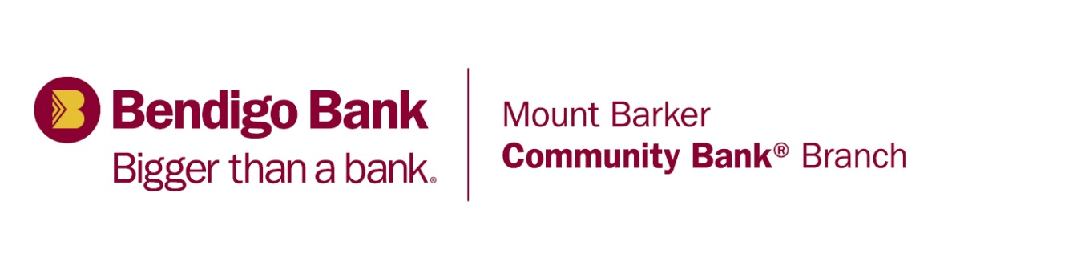

What it means to be
Bigger than a bank.

At Mount Barker Community Bank® Branch we recognise that local clubs, projects and community groups are an important part of the community. That’s why we show our support in many different ways – with over $1m invested back in to our local communities in over 17 years of operation.

As a Bendigo Bank customer you benefit from a great range of competitive products and personal service, plus the satisfaction of knowing your banking is contributing to Region community.

It’s not a new thing, it’s simply who we are and what we believe in. We think that Bendigo Bank can only be successful if our customers and our communities are successful.

So just by banking with us, you’re automatically part of something bigger.

Drop in to your local branch and meet our friendly team of staff and be part of something bigger.

Mount Barker Community Bank® Branch and Walpole Agency are proud to support our communities through our funding program. Like you, we have a strong emotional attachment to our community.

We love the idea that local people own the Mount Barker Community Bank® Branch and Walpole Agency and that by banking with us profits earned are re-invested directly back into our community. Decisions about where these profits are spent are made at this grass roots level.
The amount of sponsorship funds available to the community relates directly to the amount of business our locally owned Community Bank® Branch does.

Since opening in late 2001 we have distributed over $1,000,000 back to the community. As the number of banking customers grows, so too does the capacity to sponsor more organisations in the future.

Our funding pool is limited and requests for sponsorship always exceed our available funds, so applications are considered on their value to our community.

Please note for certain applications it is possible that a second application form will need to be completed to meet the requirements of our Community Enterprise Foundation account.

What is sponsorship?
In general terms, a sponsorship is a partnership whereby funding is provided for a club or activities that benefits both the local community, and provides exposure and opportunities for the Mount Barker Community Bank® Branch and Walpole Agency to spread the word on how Community Banks differ from mainstream banks and directly benefit the local community.

Objectives
We look for sponsorships that are mutually beneficial. The funds we are able to distribute back to the local community relate directly to the success of our banking business – that is, the more banking business we have, the more funds to go back into the local community.

Mount Barker Community Bank® and Walpole Agency offers a full suite of financial products like other banks BUT our big difference is that the majority of our profits stay right here, in Mount Barker and Walpole.

Consideration will be given to funding the following:
- Activities that strengthen the community of the Shire of Plantagenet and Walpole area.
- One-off projects, activities or events that promote physical activity and participation, showcases the area, stimulates the local economy and attracts people to the Shire of Plantagenet and Walpole area.
- Purchase of capital items that build on the capacity of a community group and its ability to provide a service to the local community.
- Activities that promote sportsmanship, participation and encouragement to citizens across the Shire of Plantagenet and Walpole area.
- Individuals are not considered.

Specifically, the Mount Barker Community Bank® Branch and Walpole Agency looks for sponsorships that offer:

Applications will be assessed against the following factors:
- Supports the vision and values of the Community Bank®.
- The application is complete and provides information about how the funds will benefit the community.
- Collaboration with other community groups.
- How your project can generate business for the bank and generate more resources available for our community.

Your organisation can assist Mount Barker Community Bank® with the following
- Networking opportunities within your membership to grow our business and help give back more to the local community.
- Media opportunities that demonstrate how the bank is supporting your organisation. ie. radio, press, social media, signage
- Photo or presentation opportunities for the Community Bank®.
- Potential for long-term, mutually beneficial partnership.
- Opportunities to include messages and advertisements in newsletters and other community correspondence.

Guide to completing the application form
This information directly corresponds to the information required on the application form which can be obtained by emailing pcfs@westnet.com.au or dropping in to the Mount Barker branch at 4 Short Street, Mount Barker or Walpole agency at 44 Latham Street, Walpole.

Section A – This information is required to enable us to process your application and to have correct contact details should further information be required.

Section B – What do you plan to do? What are the projects outputs and outcomes? Who will benefit from the project? Please consider the ‘SMART’ principle in your application, i.e. Specific, Measurable, Achievable, Realistic and associated with a specific Timeline. If successful in receiving funding, you will be required to report against these outcomes.

Management and monitoring of the project – Who is going to be responsible for managing the project on behalf of your organisation and what qualifications, skills and experience do they have.

Project costs and funding sources – Applicants should demonstrate a high level of financial commitment to the project through sourcing other project funding and/or a direct financial contribution to the project. If your project is unable to source supporting funds this should be stated with a clear explanation as to why this is the case.

Give details of the total project budget. Include details of your budget expenditure; include financial and non-financial (in-kind) contributions from all parties. It is important that this information is clearly explained.

Wherever possible, please attach documents that support the budget request.

Give details of all your funding sources. Identify where the funding is coming from, what it will be used for, and if it is approved or requested. If it is requested but not yet approved provide details of when a decision is expected. If applicable, attach written evidence of funding contributions from other sources.

Section C – Please consider promotional aspects (e.g. signage) or your project.

Section D – Special conditions for applying for sponsorship. Please ensure you read through these.

Section E – Terms and conditions upon acceptance of sponsorship. Please ensure you read the terms and conditions carefully.

Section F – Application checklist USE IT!

Section G – This declaration must be signed by two (2) office bearers. Ensure this section is completed in full.

